Outputs of project:
First table:
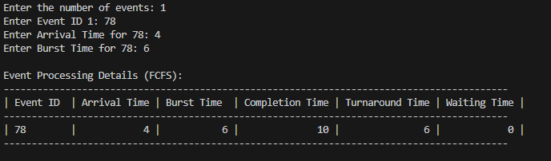
Average Waiting time & Average Turnaround Time:

Second Table:
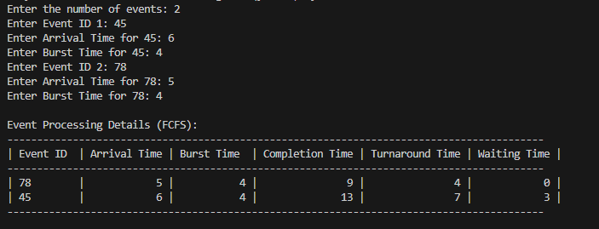
Average Waiting time & Average Turnaround Time:


